**AWS FACE DETECTION APP PROJECT DOCUMENT**

Submitted By: **AVNI SOLANKI**

Email:[**avni10.solanki@gmail.com**](mailto:avni10.solanki@gmail.com)

**Screenshots for Dashboard:**

1. **AWS Login Screen**

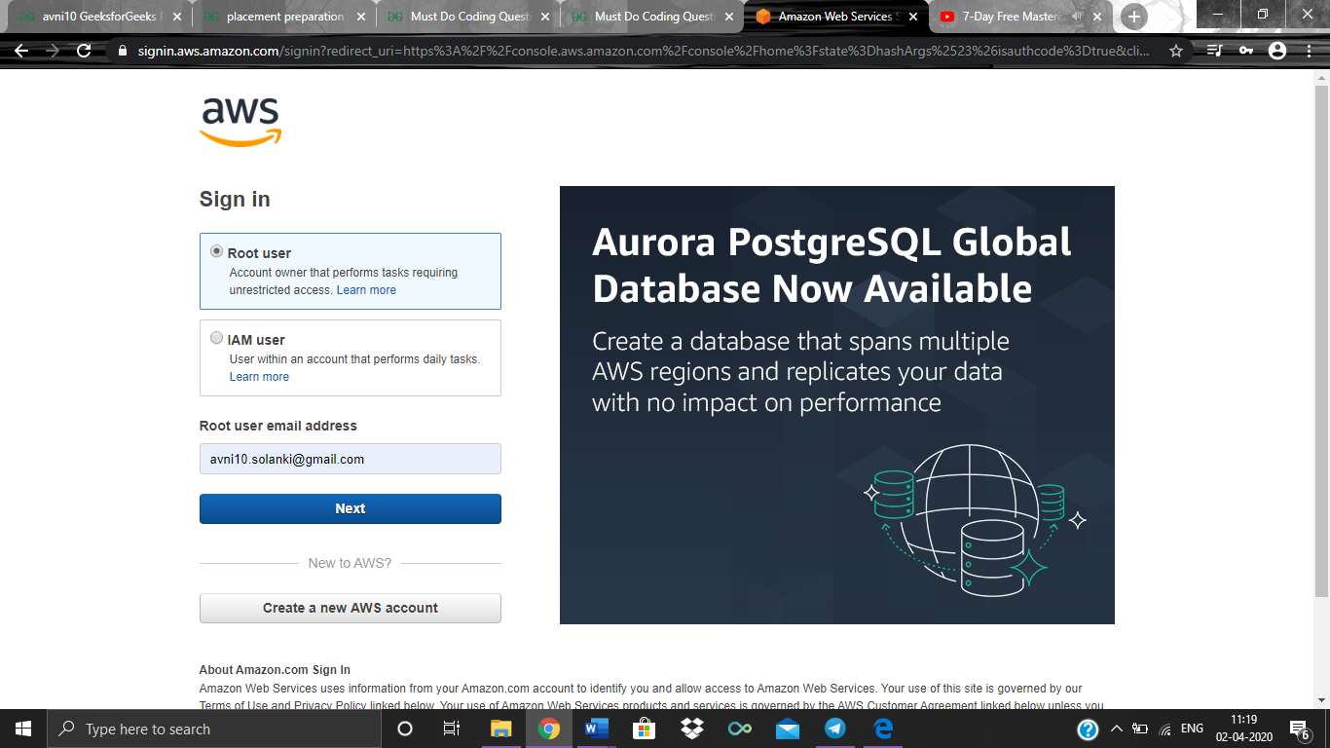

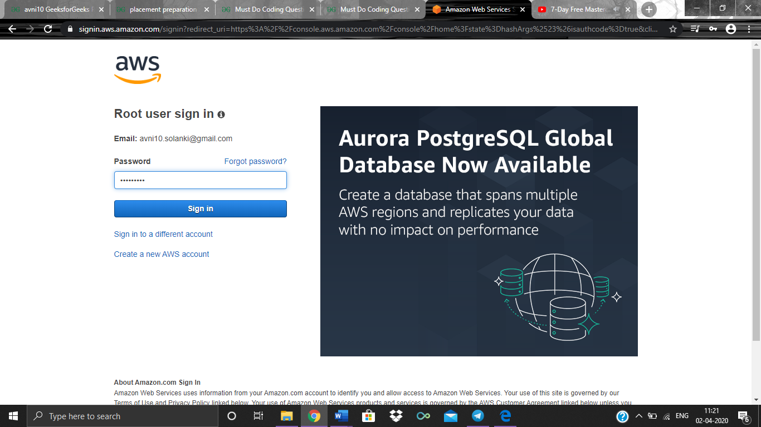

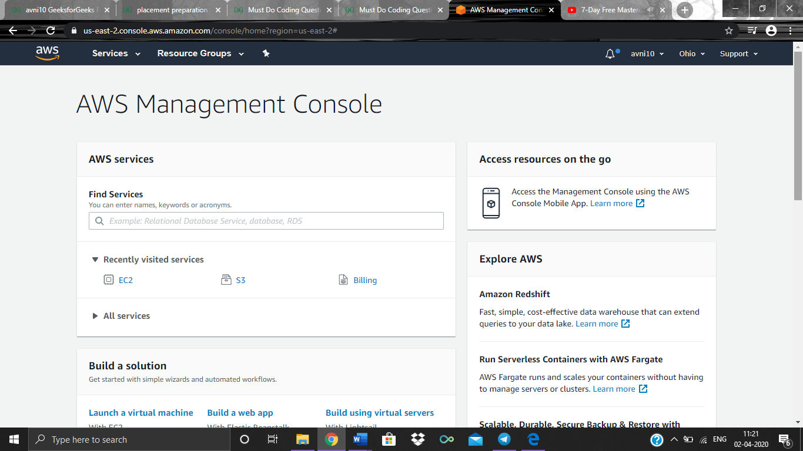

1. **EC2 Dashboard**

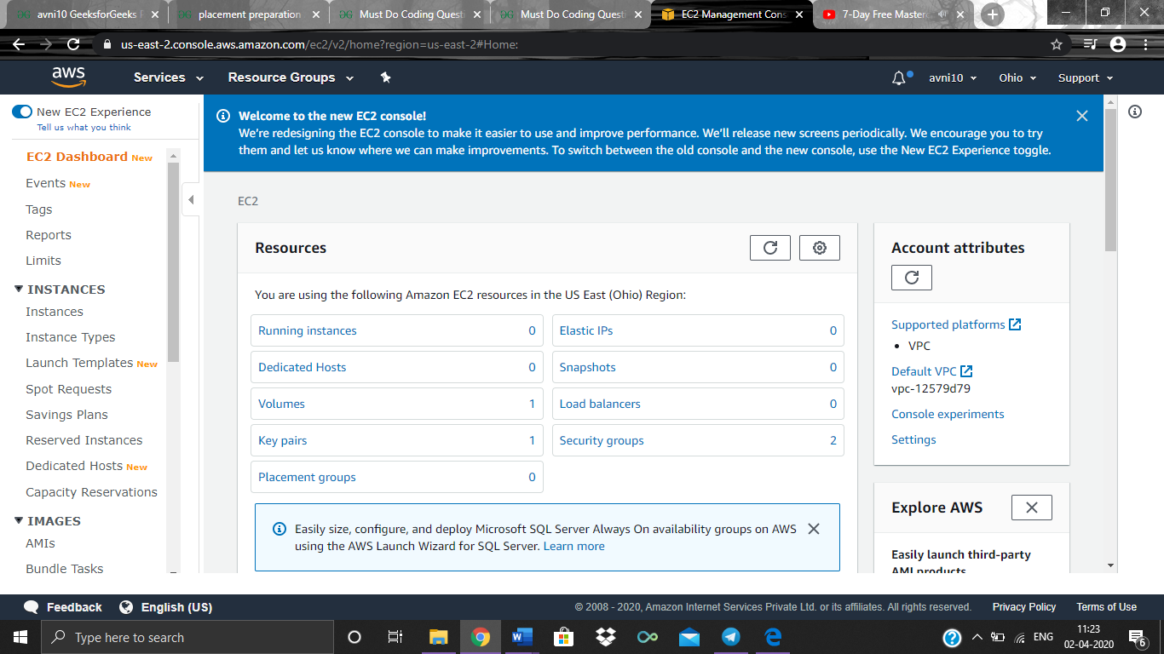

1. **S3 Dashboard**

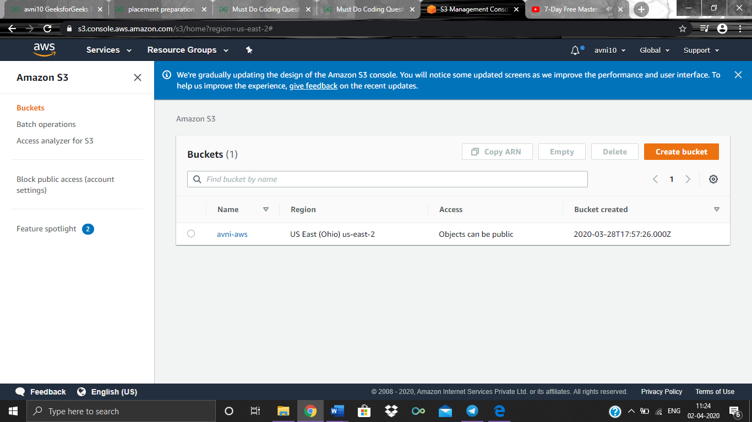

1. **Rekognition Dashboard**

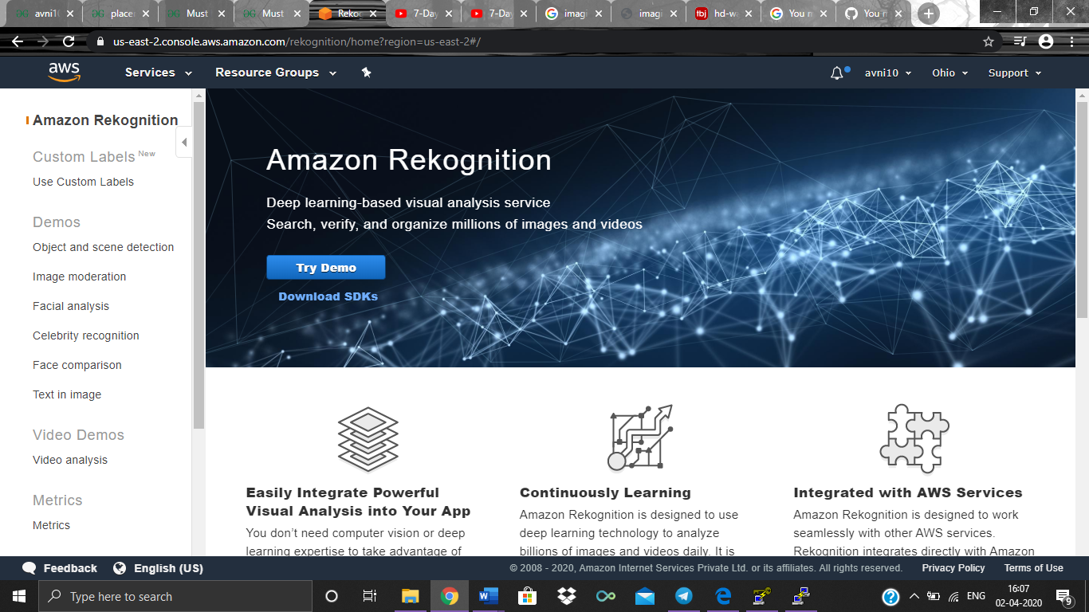

**Screenshots for EC2:**

1. **Choosing an AMI**

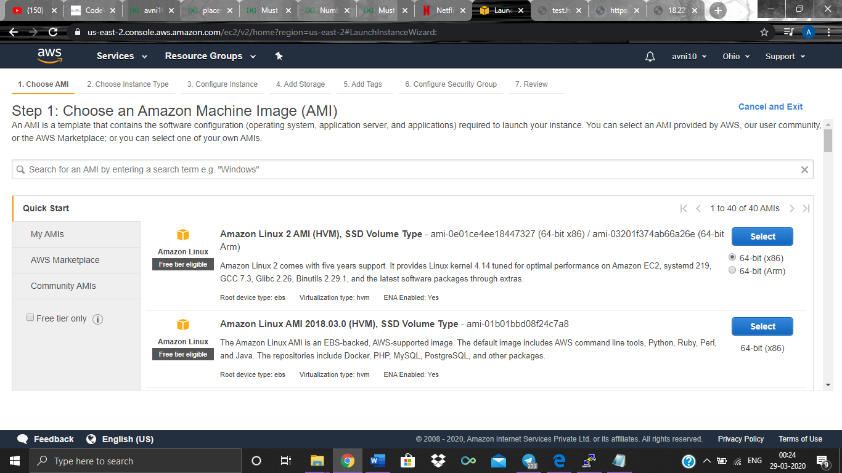

1. **Choosing an Instance Type**

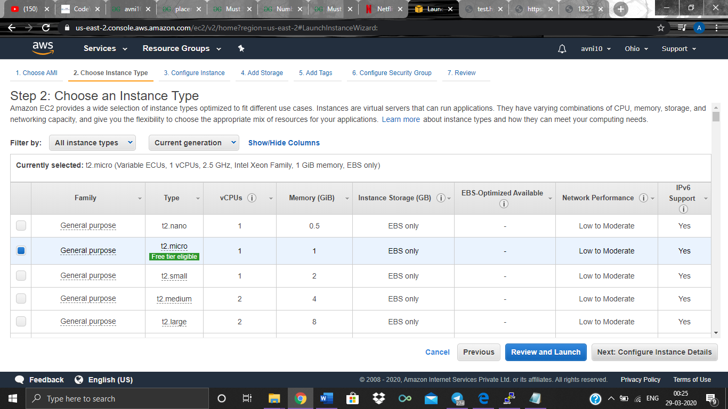

1. **Adding Storage**

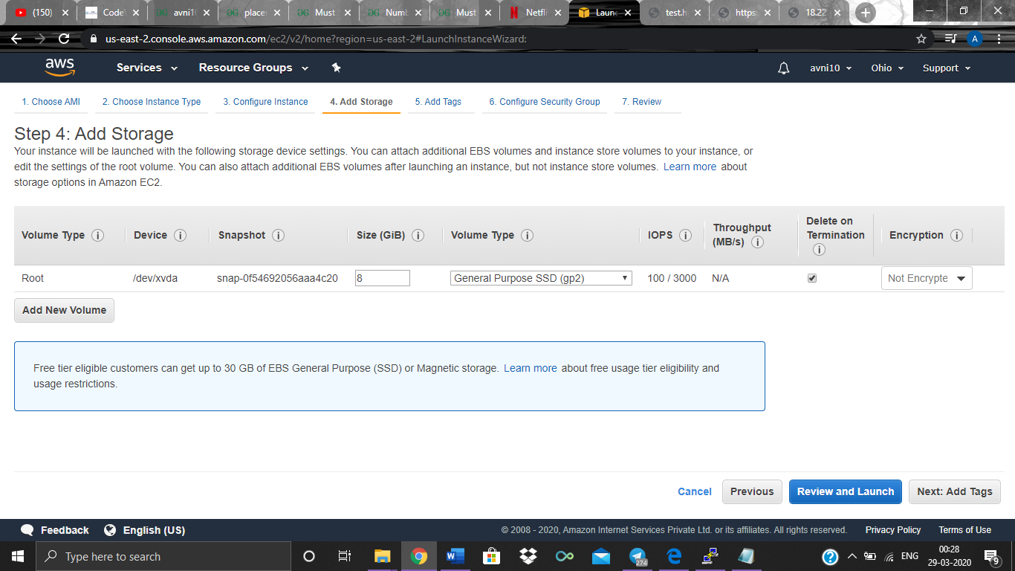

1. **Configuring Security group**

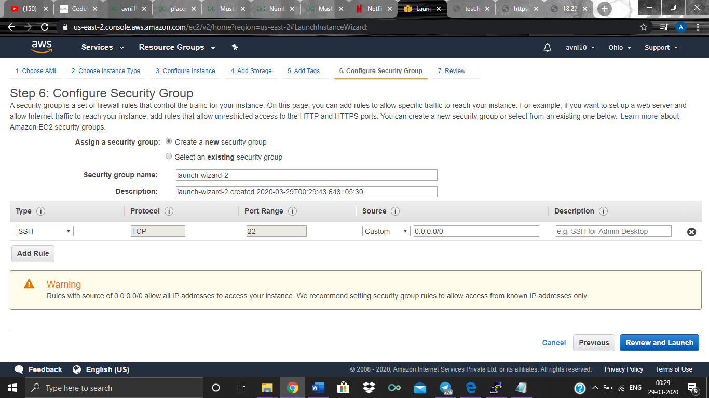

1. **Key Pair Download**

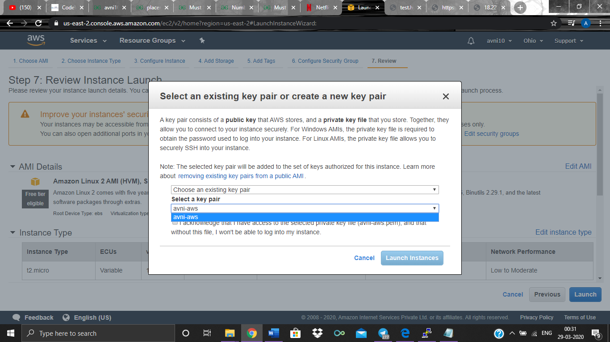

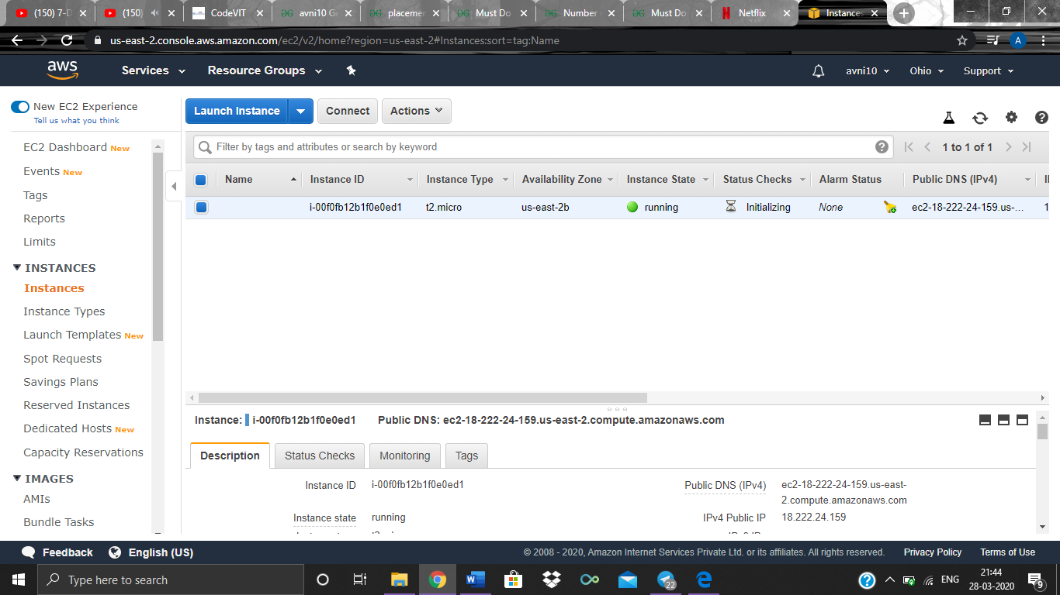

1. **PUTTYgen conversion from pem to ppk**

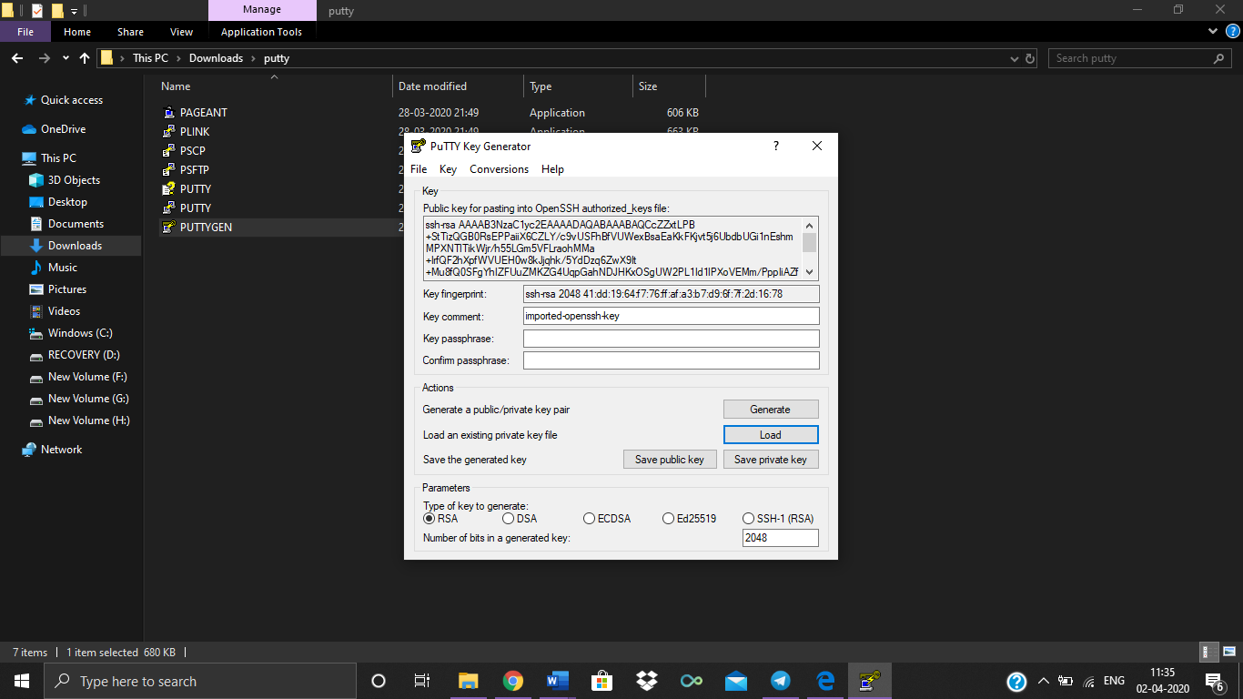

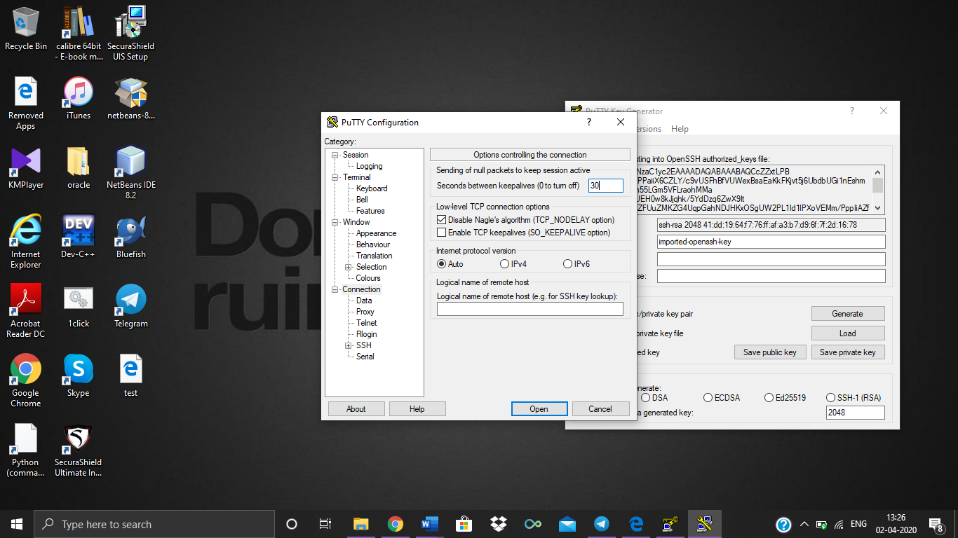

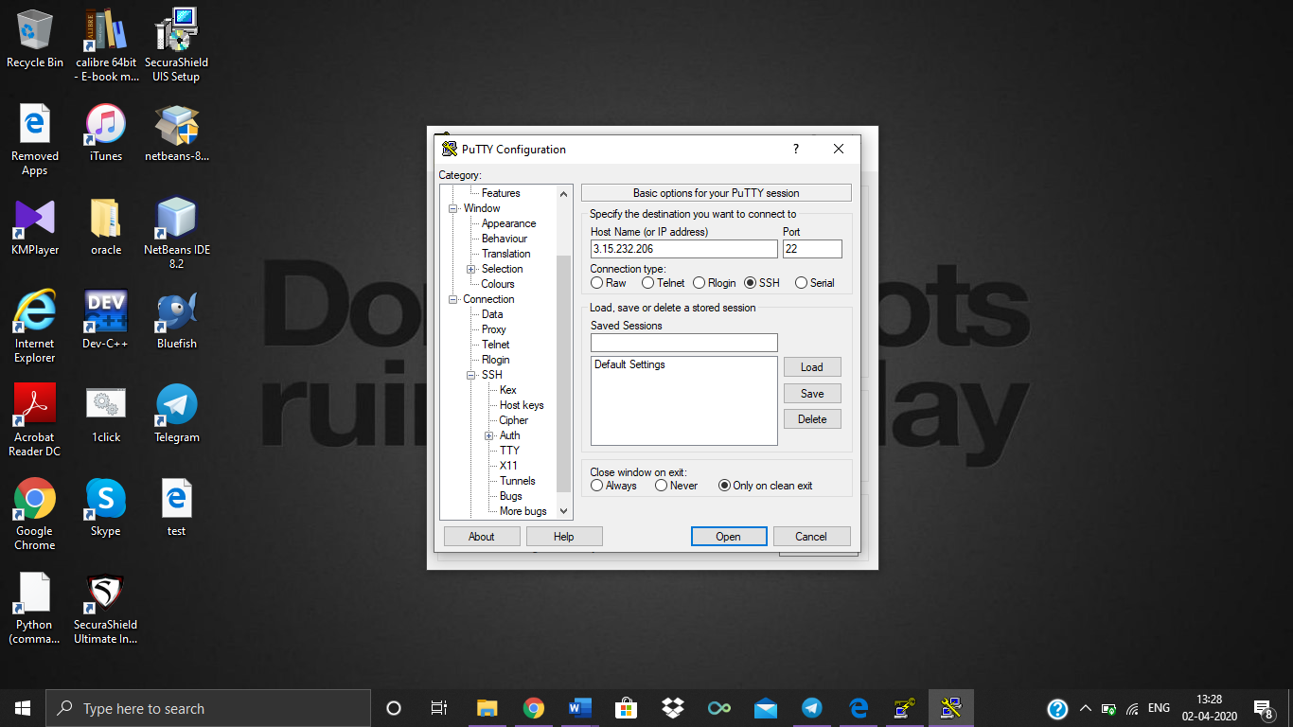

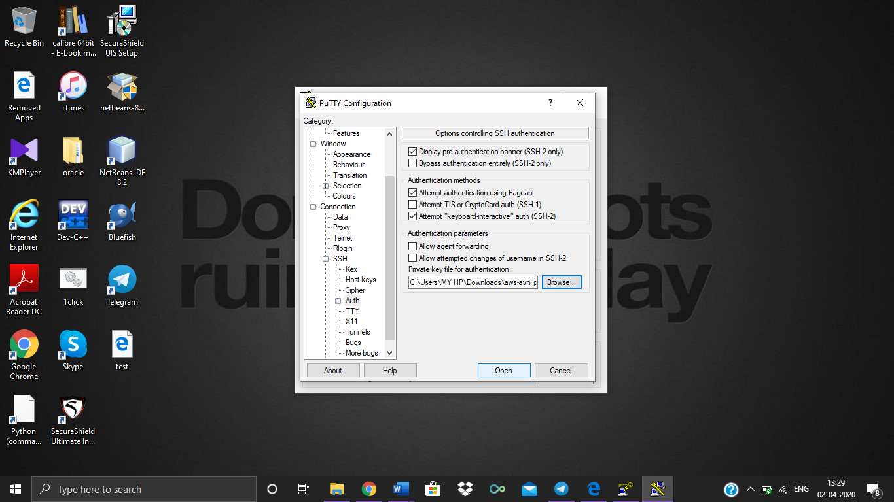

1. **Logged in EC2 screen**

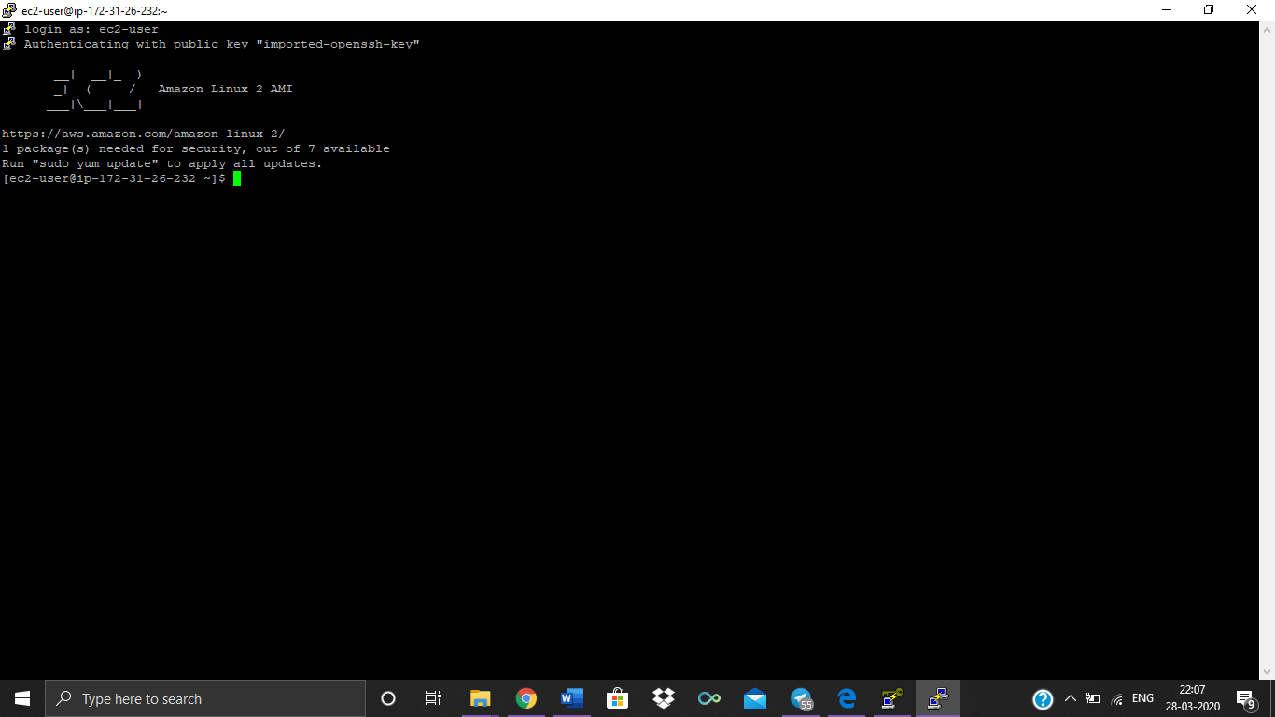

**Screenshots for S3:**

1. **Creating a Bucket**

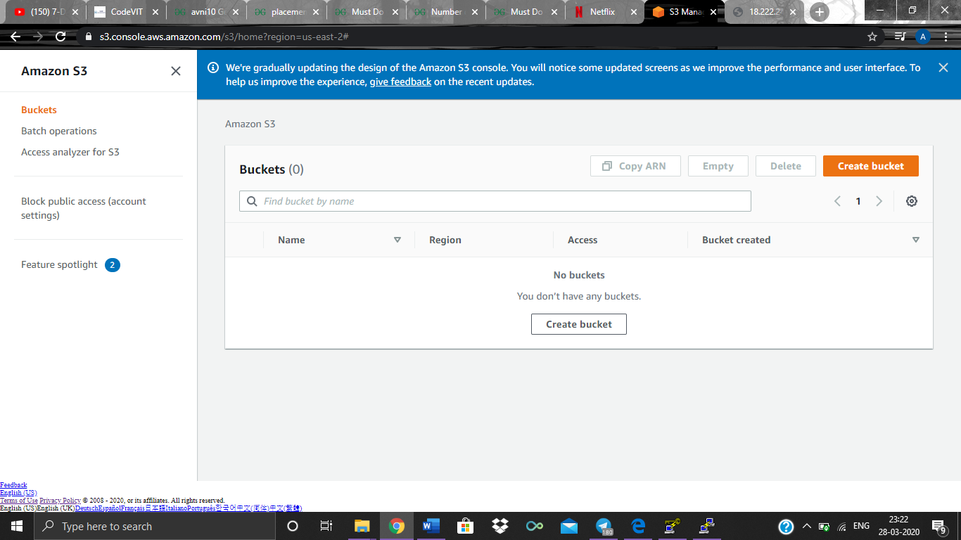

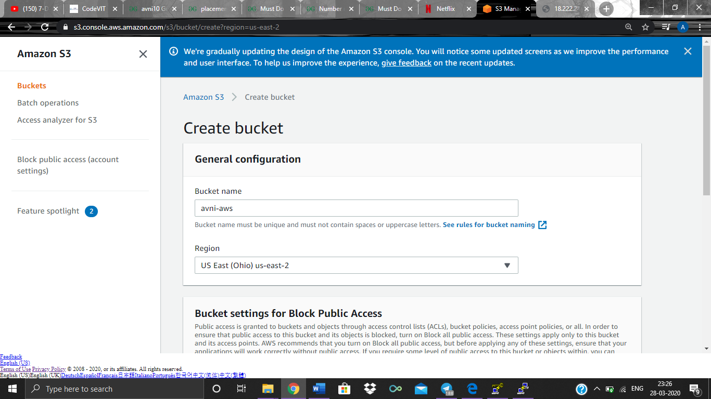

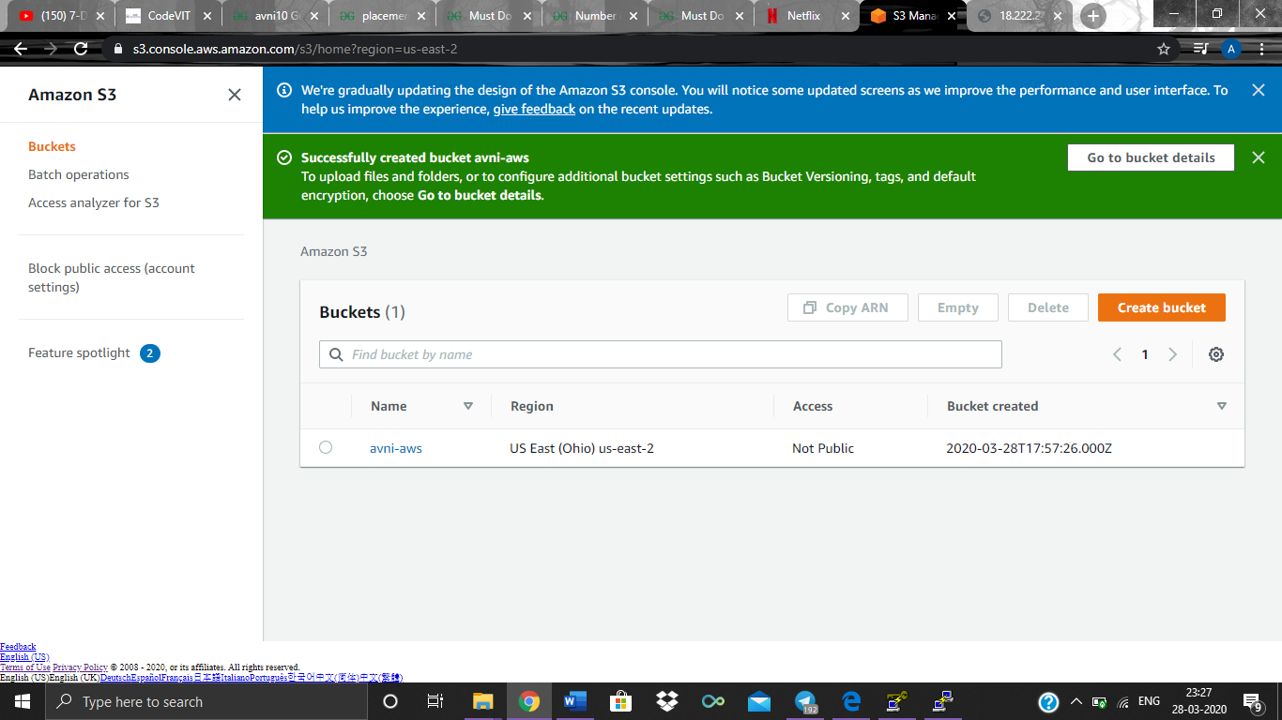

**No Region selection required in S3**

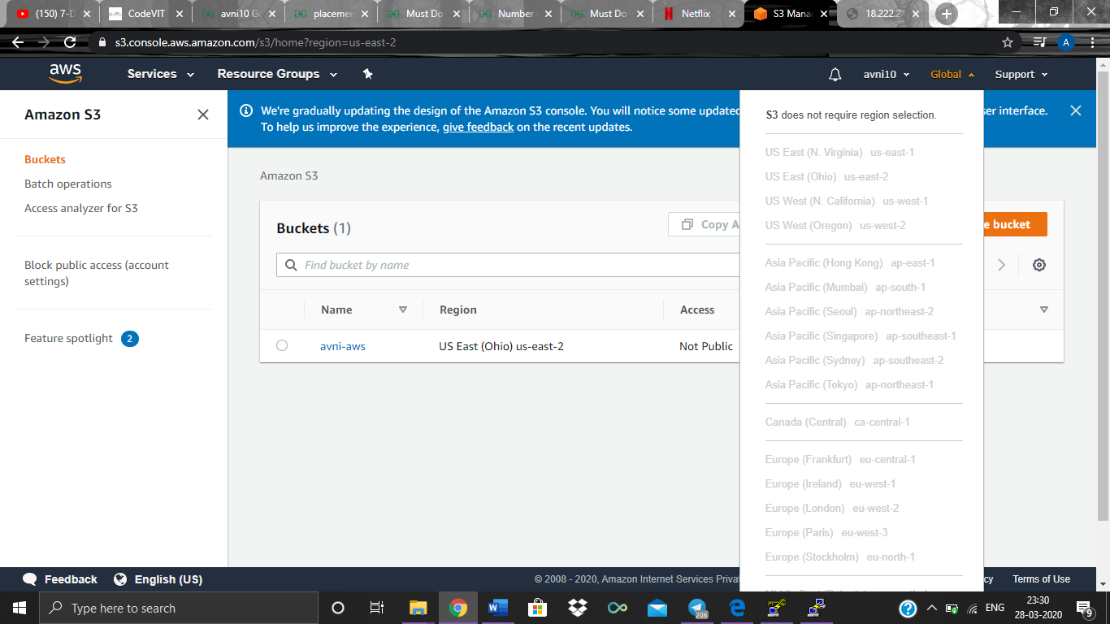

**Bucket (avni-aws) details**

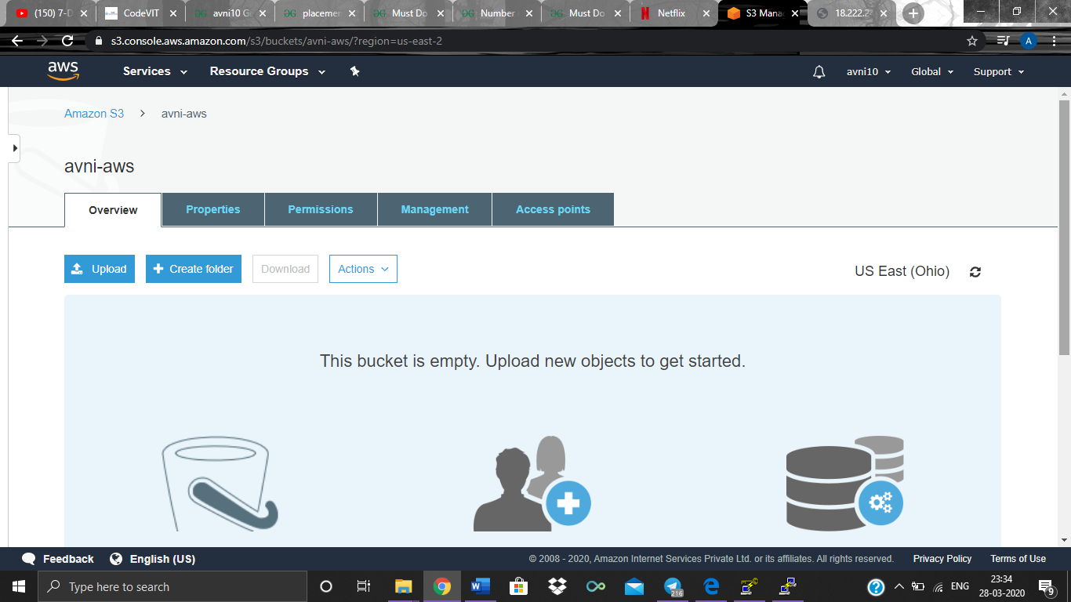

1. **Uploading an Object**

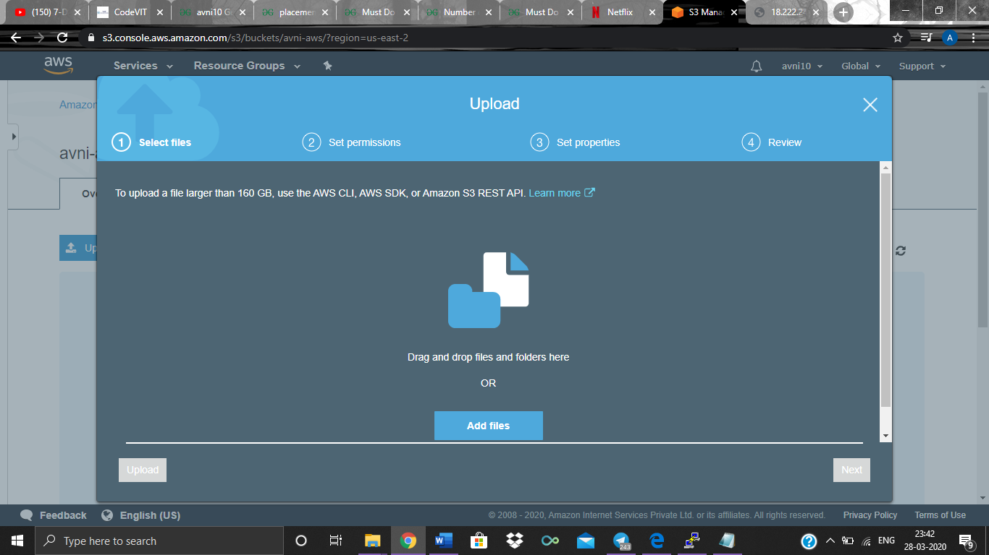

**Selecting file**

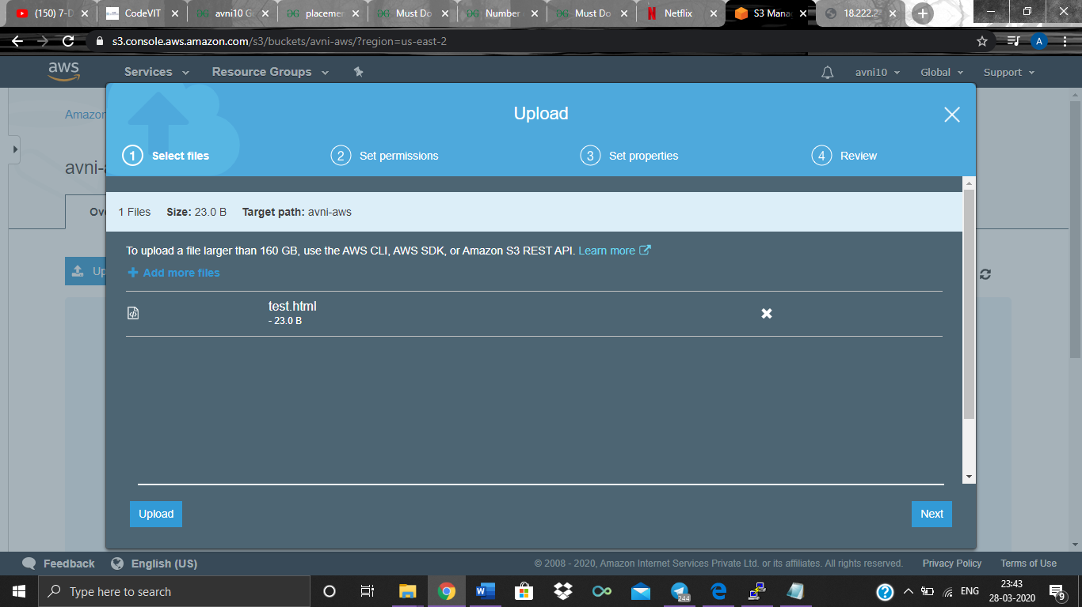

**Setting Permissions**

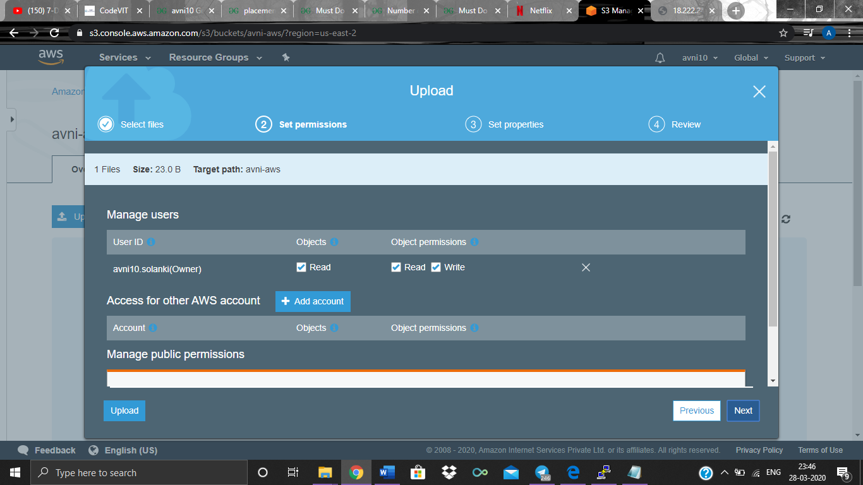

**Setting Properties**

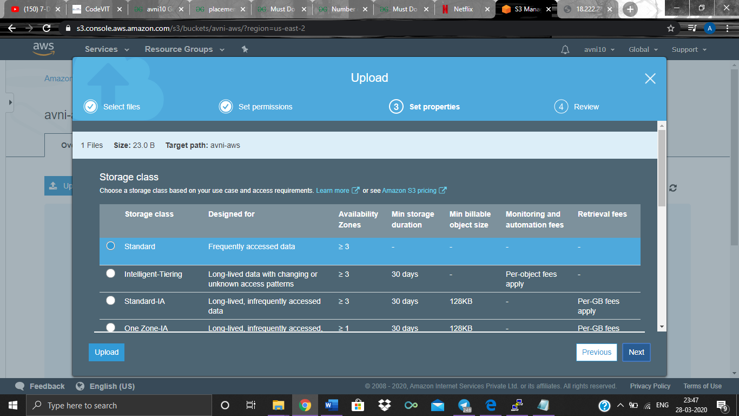

**Review and Upload**

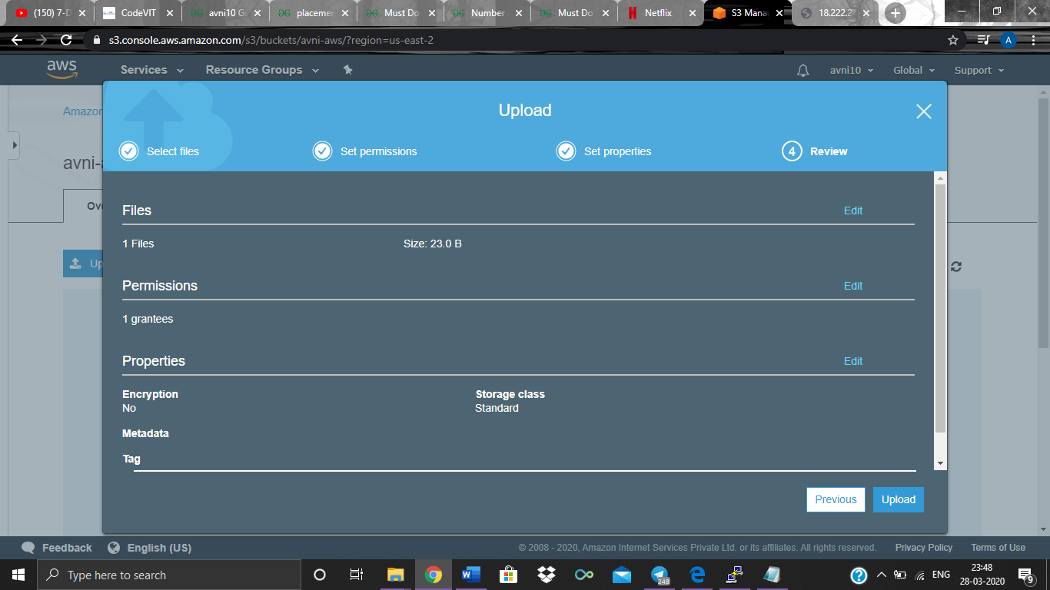

**Upload Successful**

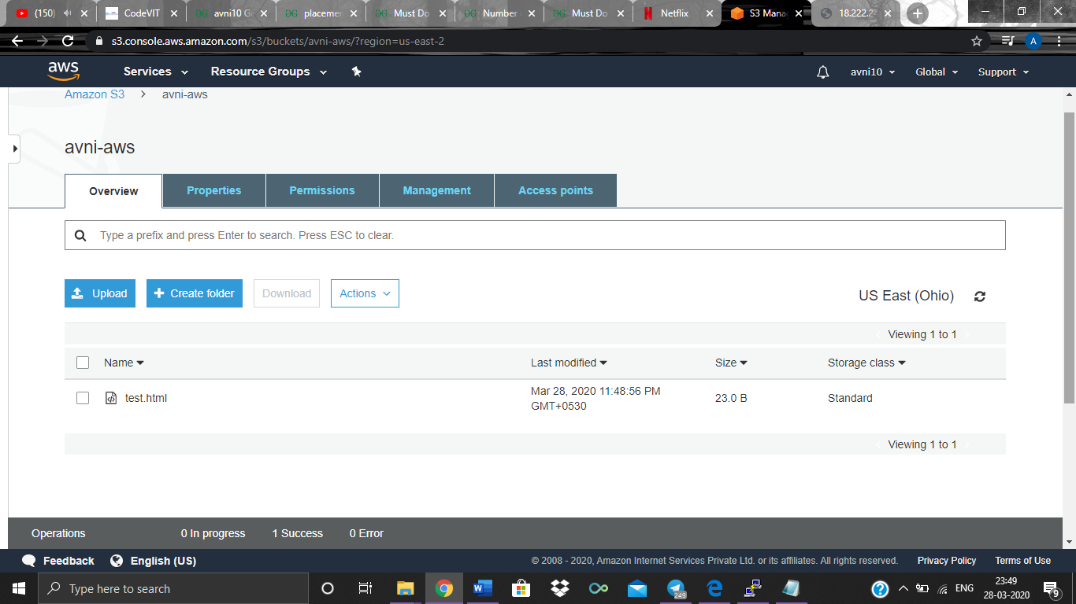

**Viewing object (test.html) details**

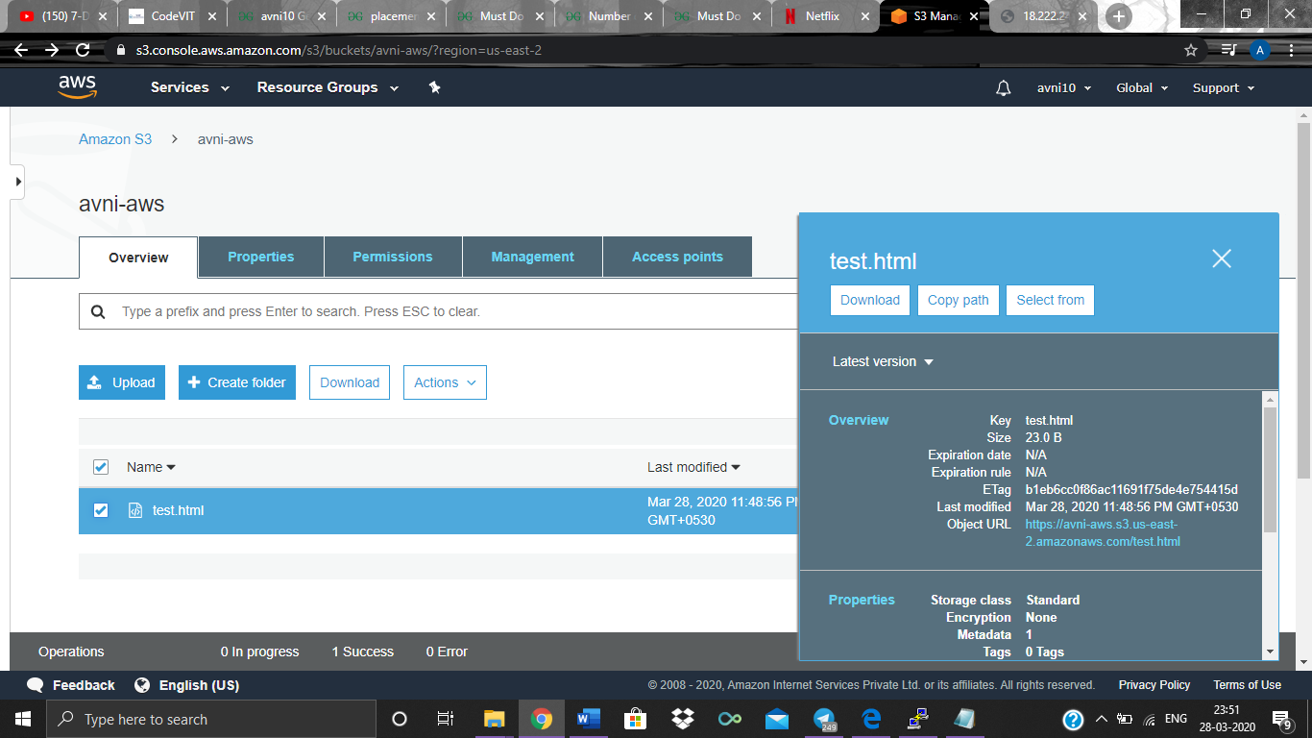

**Going through object Metadata**

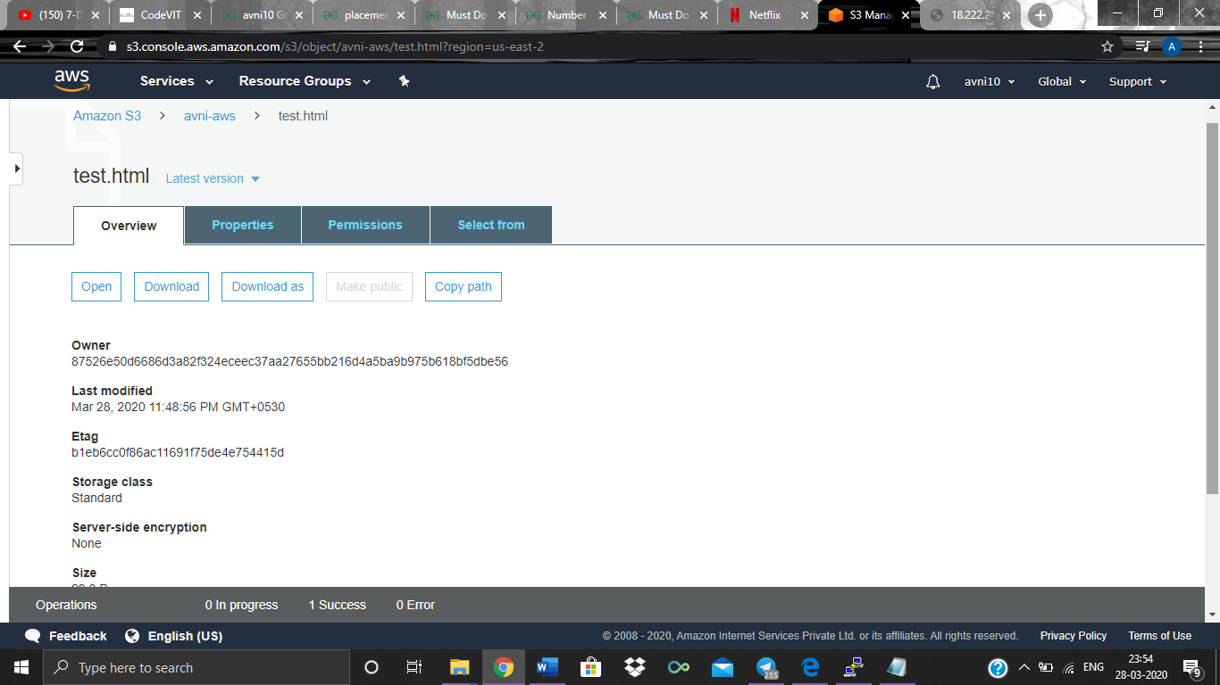

**Accessing object URL (before making it public)**

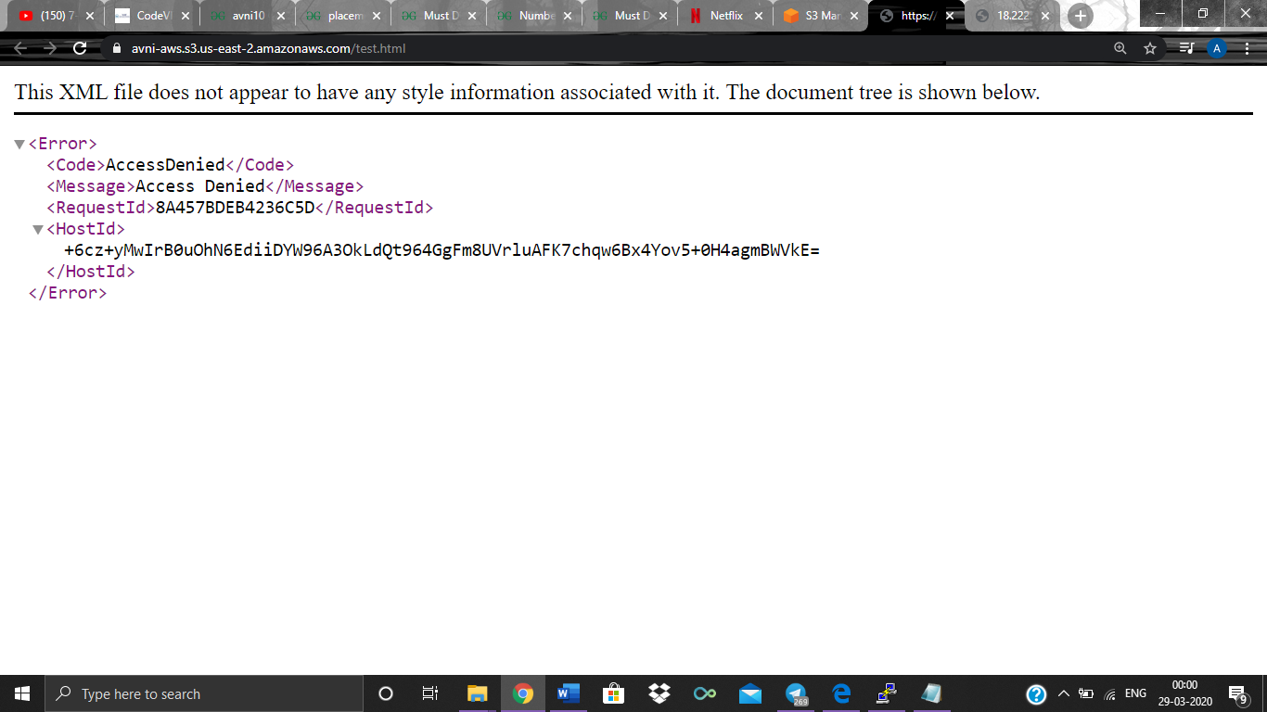

**Downloading the previously uploaded file**

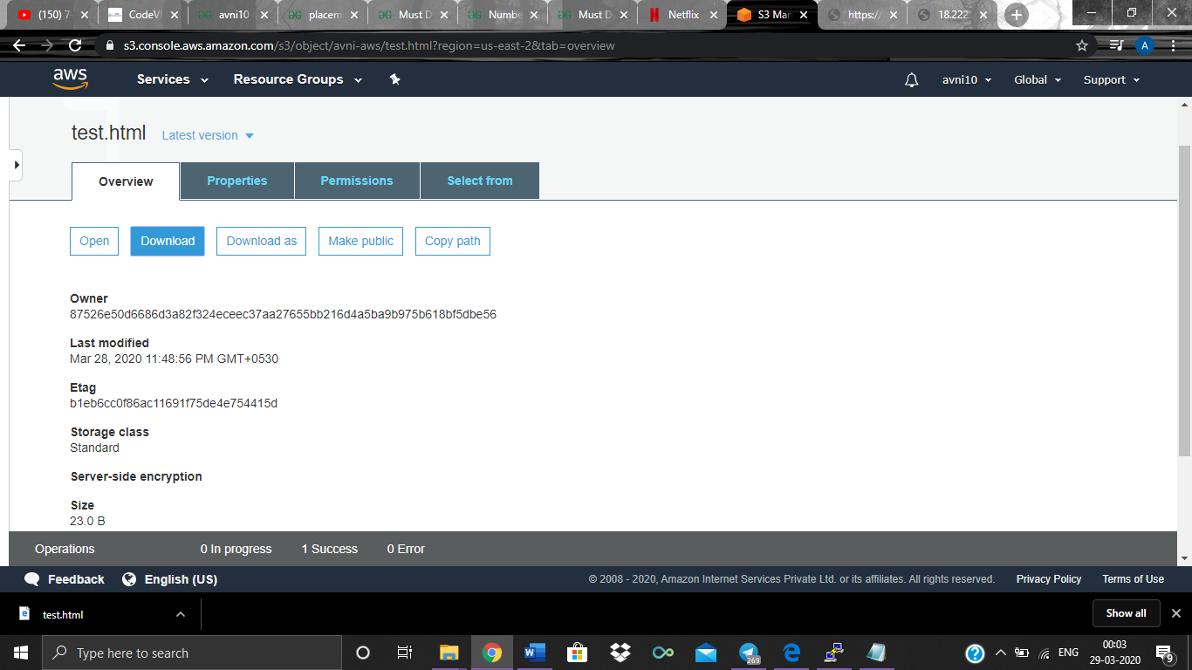

**Viewing contents of downloaded file**

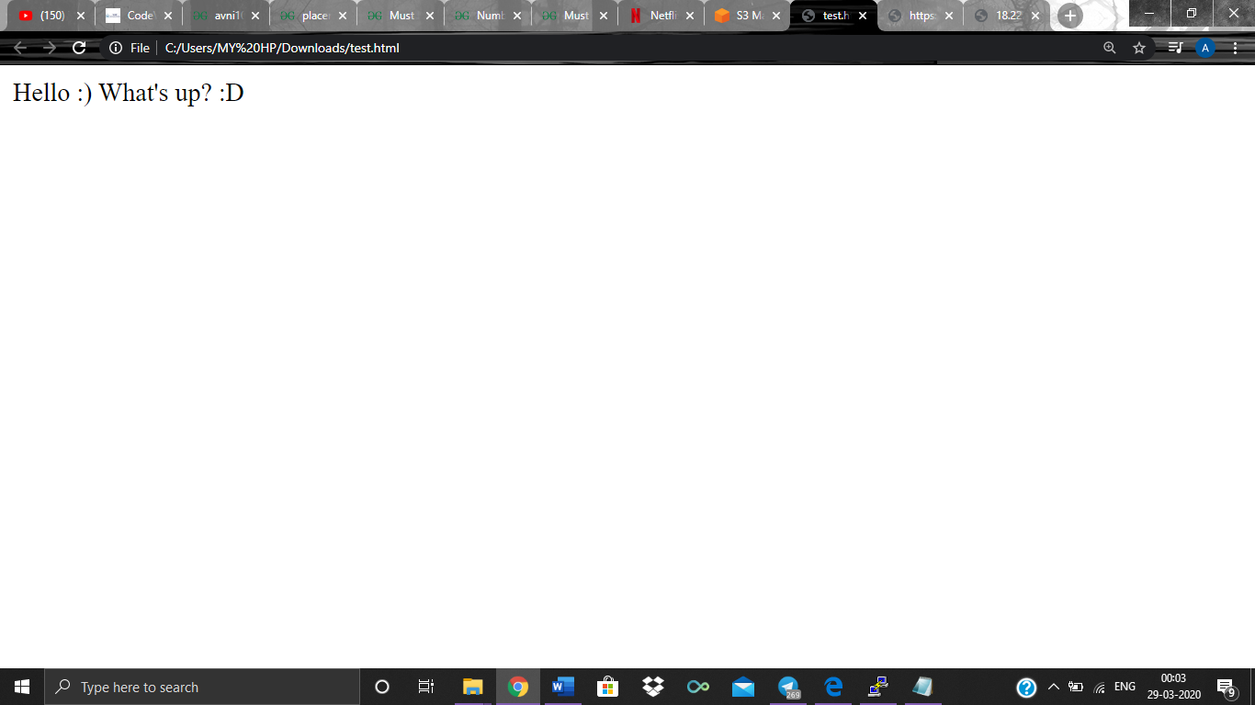

1. **Enabling Static Website**

**Properties**

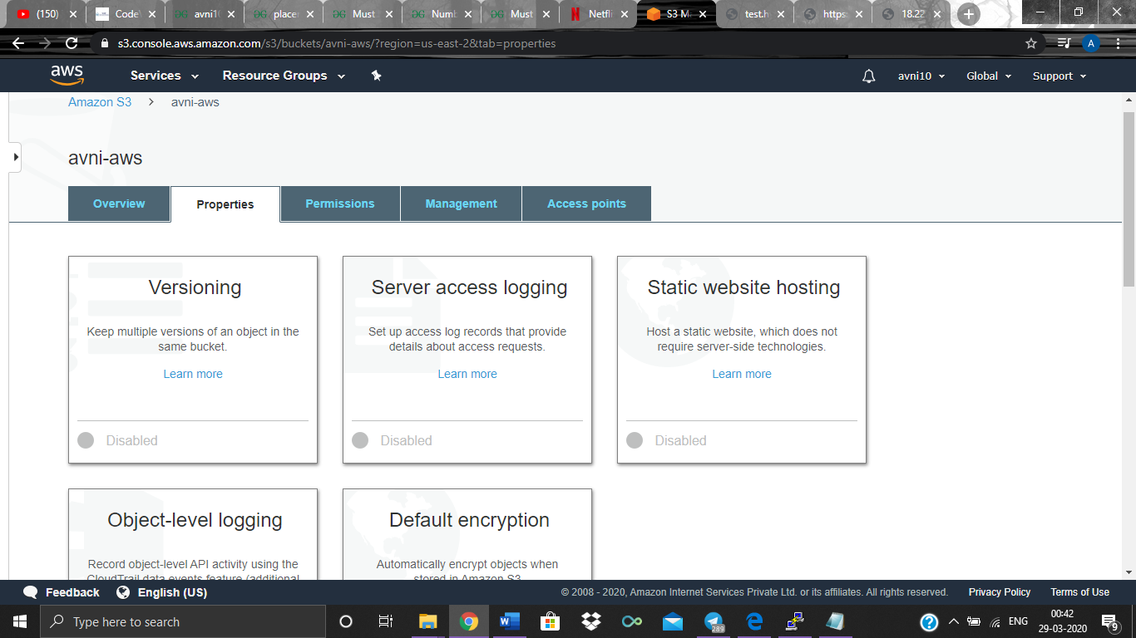

**Selecting static web hosting and choosing file**

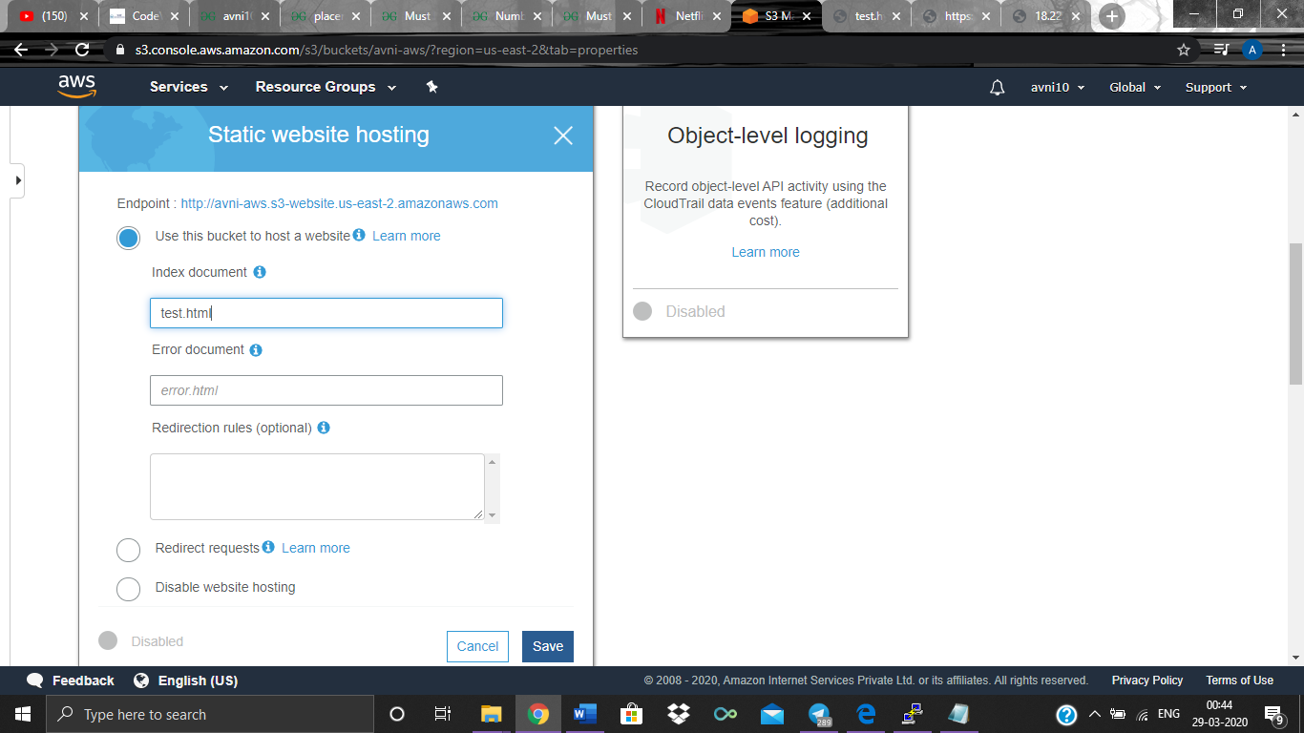

**URL is a domain name now, no longer an IP address**

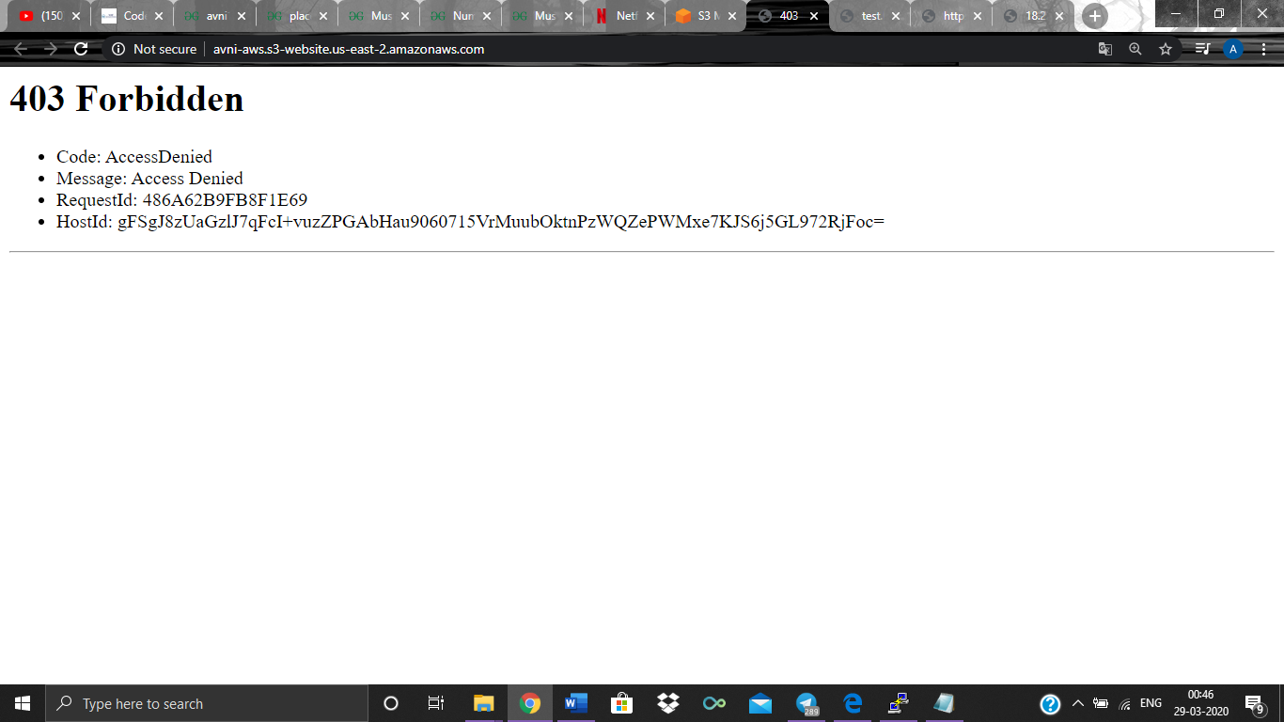

1. **Making the object public**

**Enabling public access to the Bucket:**

**Permissions Tab**

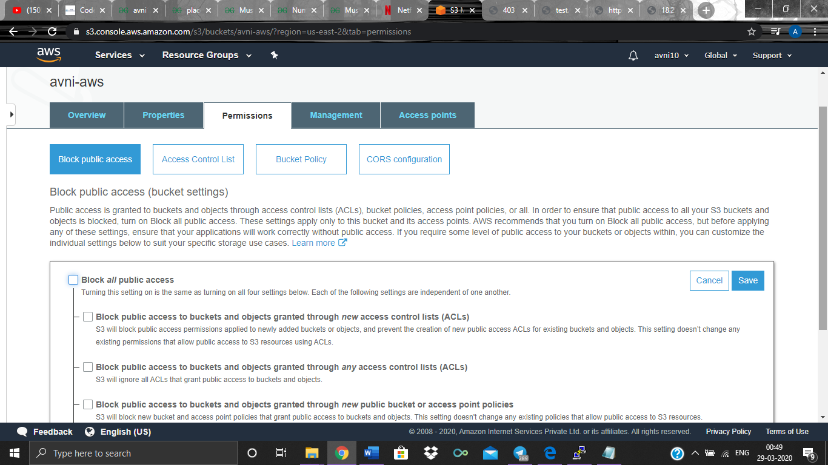

**Enabling Block Public access**

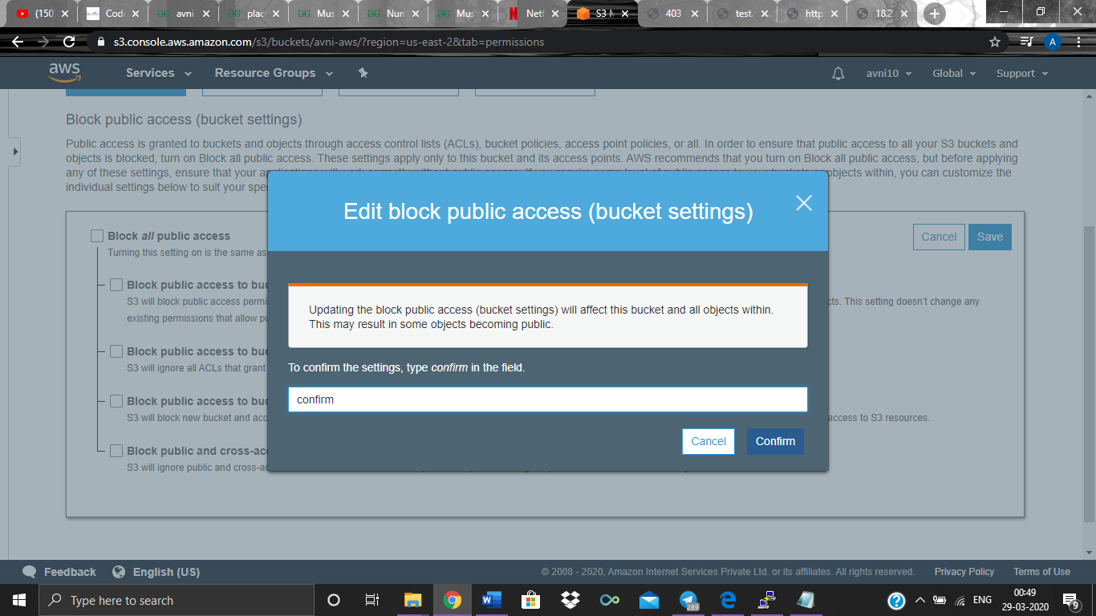

**Public access settings updated**

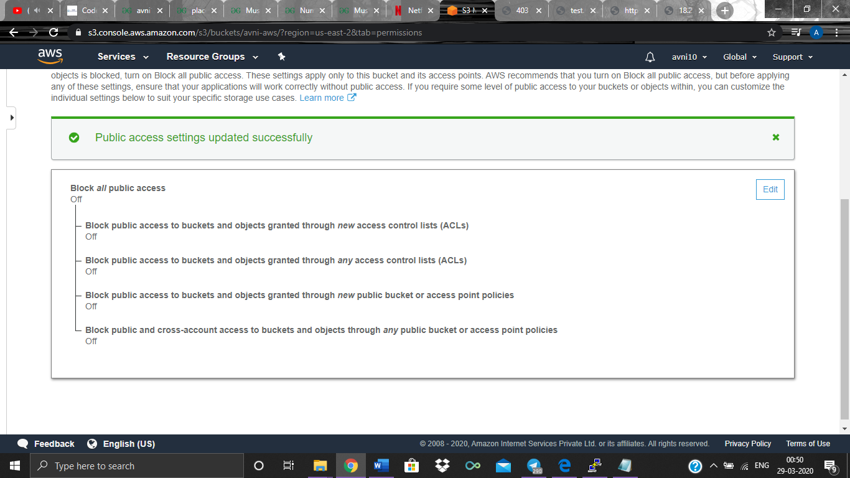

**Making object Public**

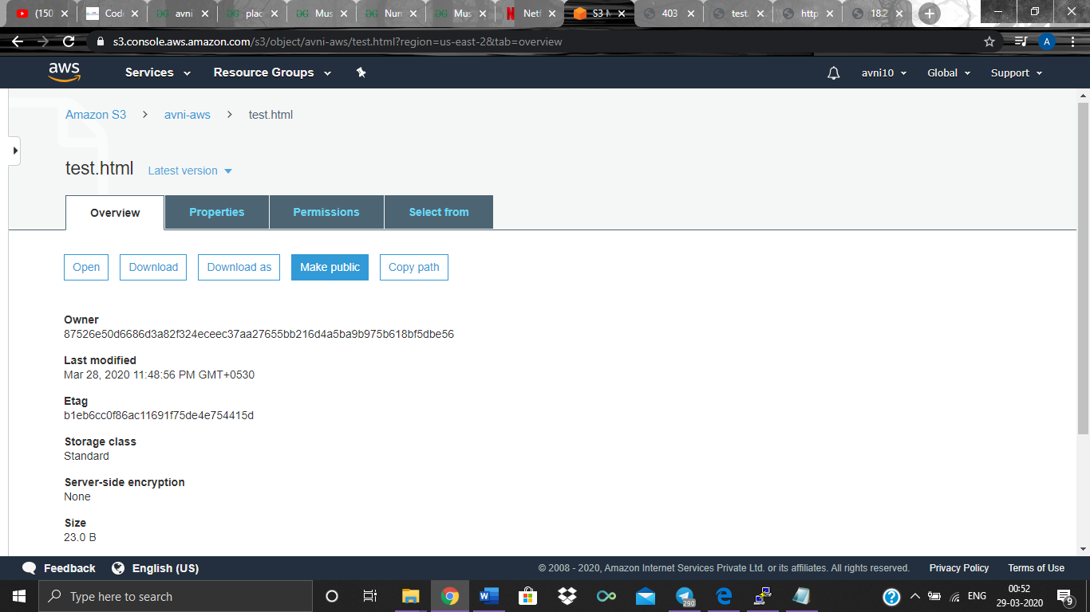

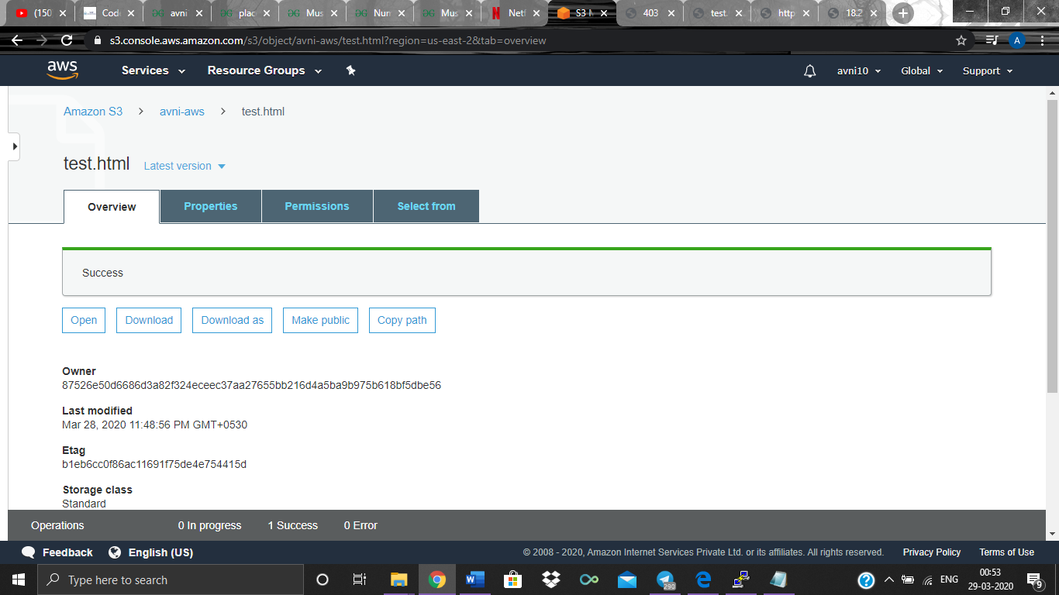

1. **Checking S3 link on the browser**

**Bucket successfully made Public**

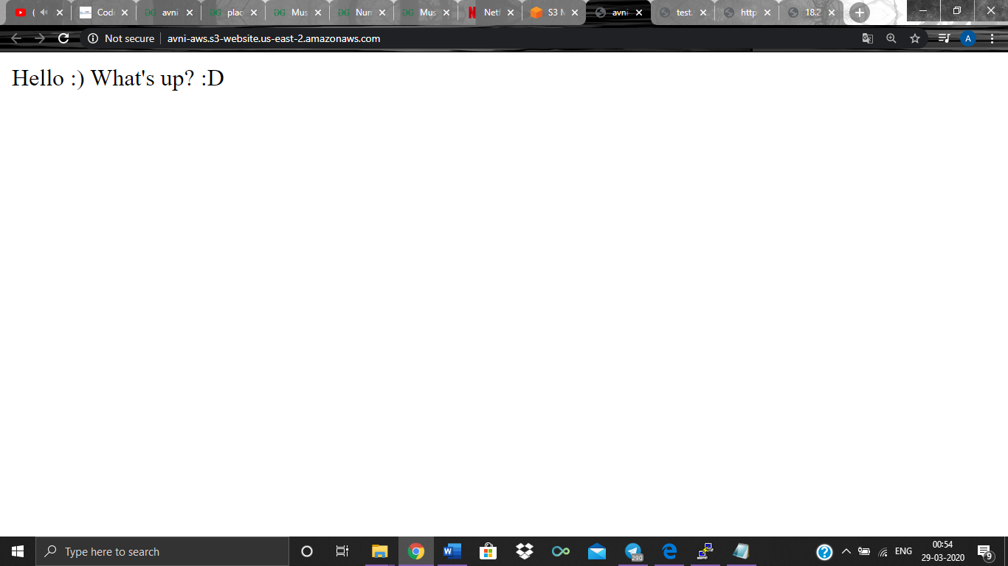

**Screenshots for Rekognition:**

1. **Face Detect (Facial Analysis)**

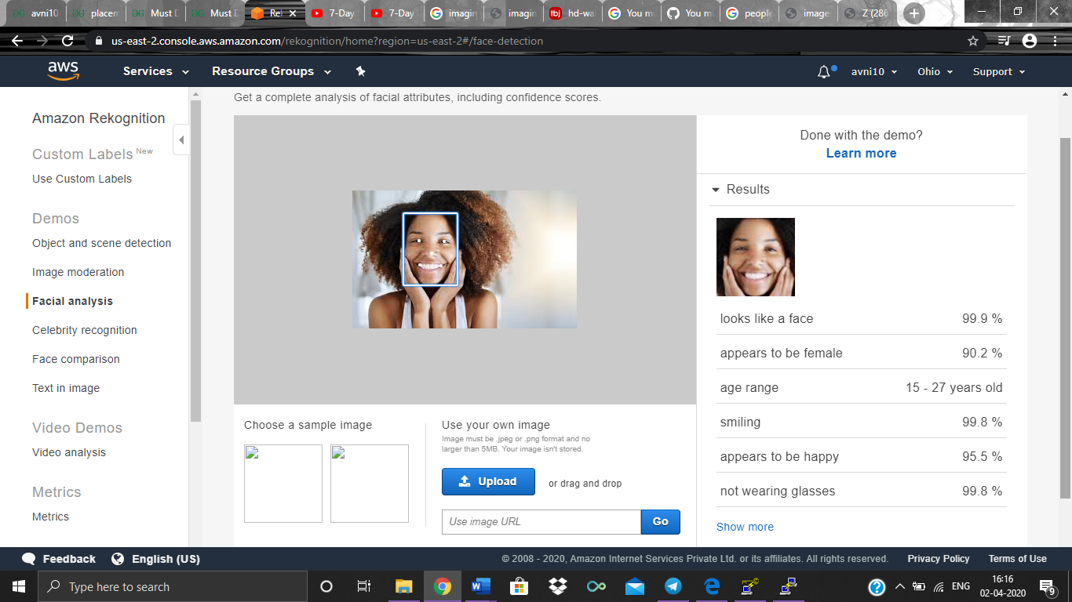

1. **Face Compare**

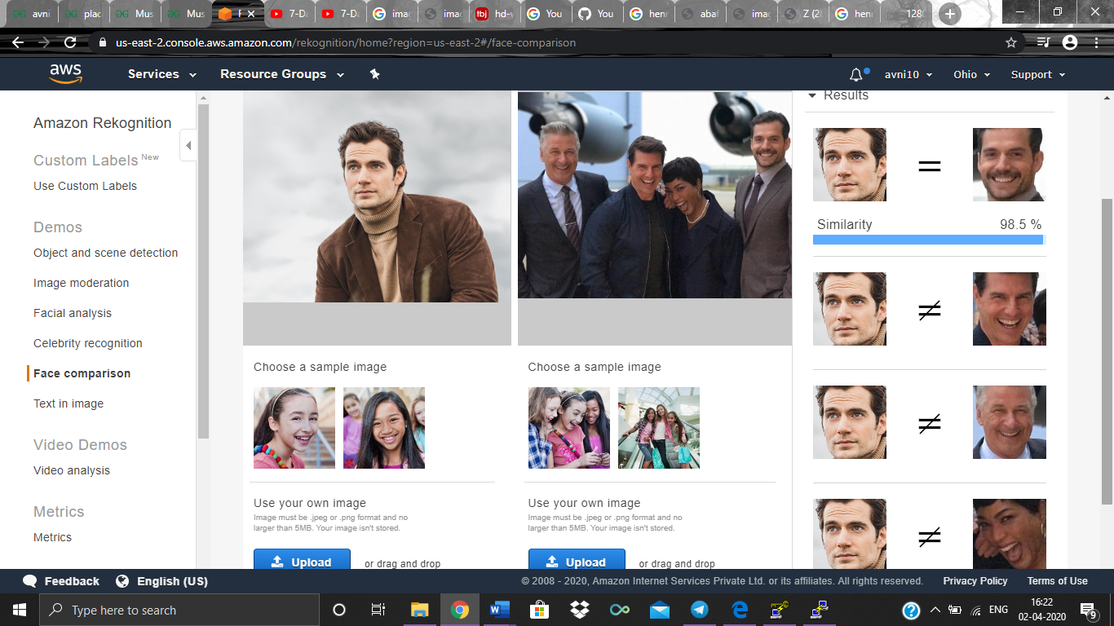

1. **Celebrity Recognition**

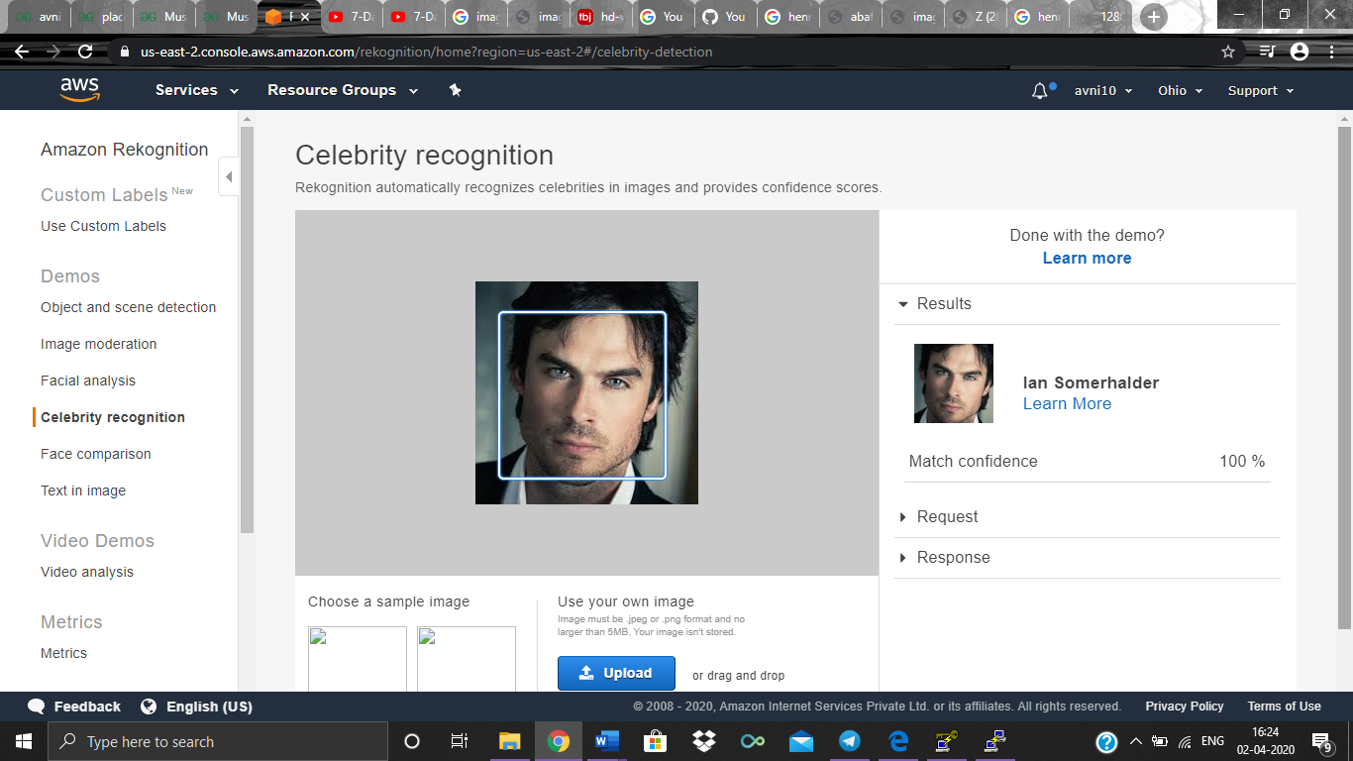

1. **Text in image**

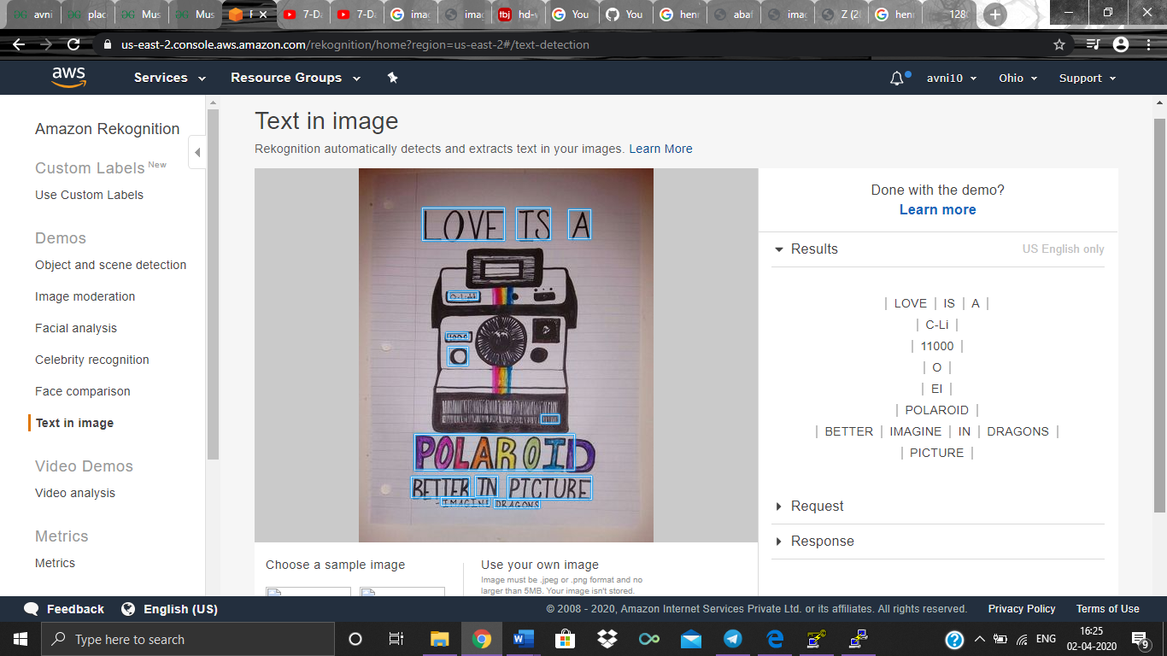

**Screenshots for EC2 and S3**

1. **Installing PHP**

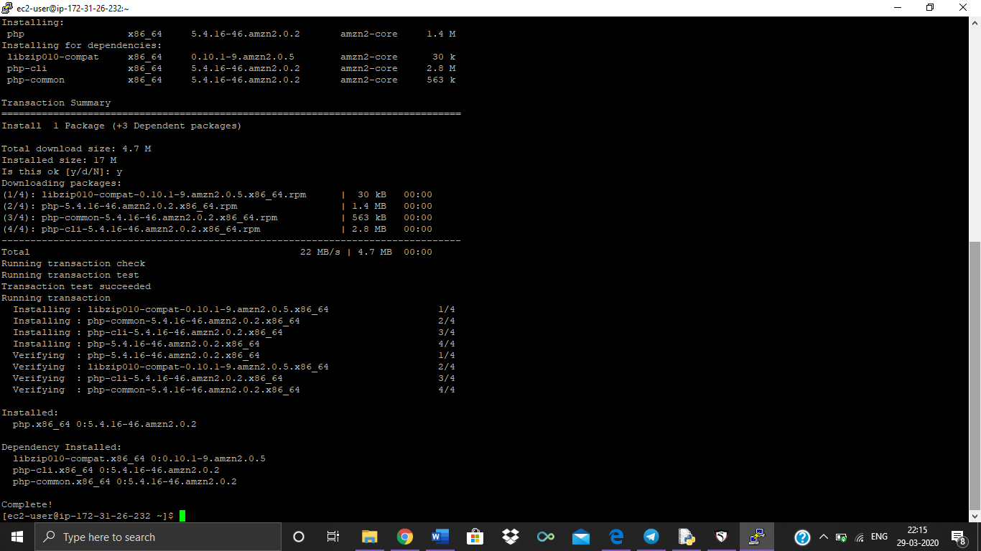

1. **Installing aws-sdk**

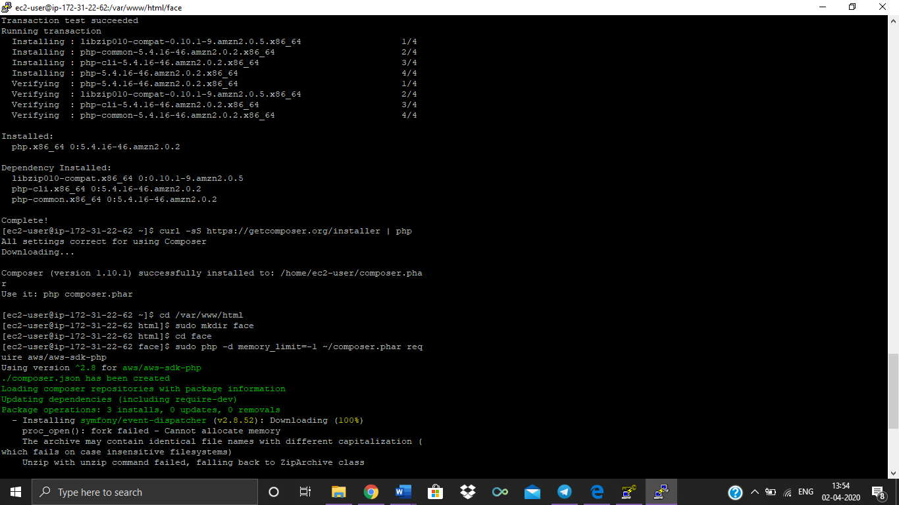

**Downloading image**

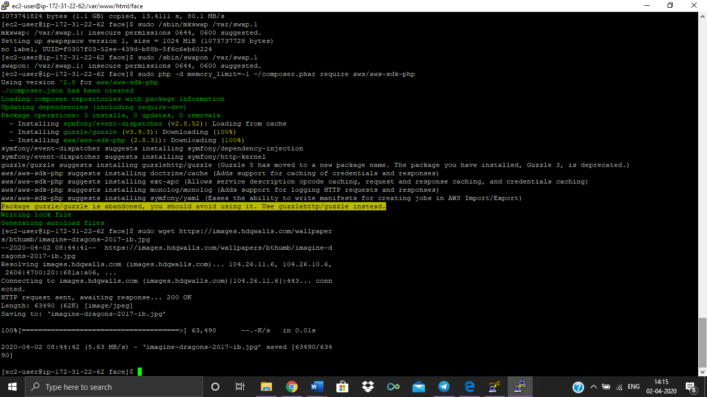

1. **Index.php file code**

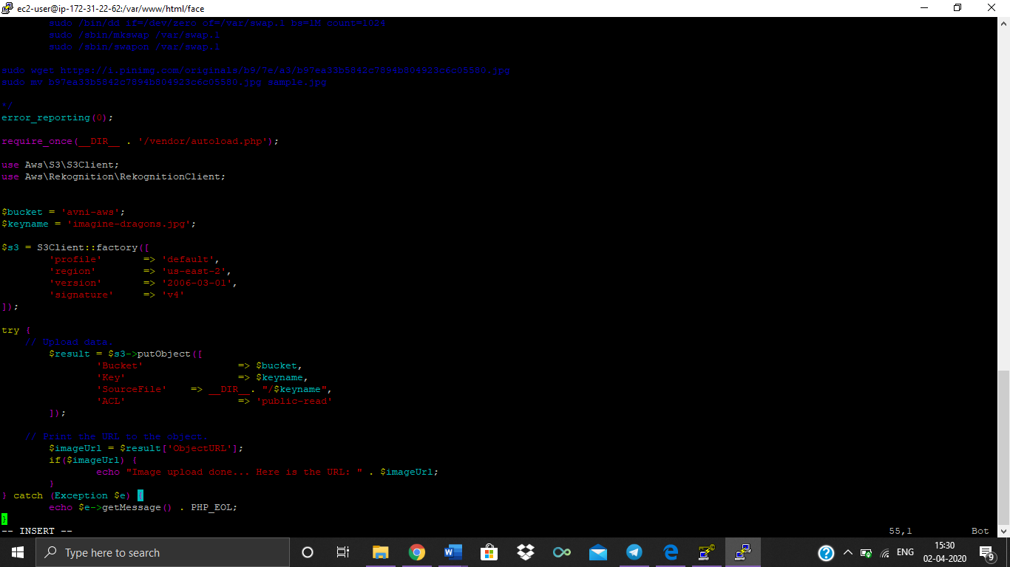

1. **Upload successful**

